30 July 2025
NSO and RST ‘collective sport voice’ initiative
Guidance pack for Online Casino Gambling Bill public submission process
Introduction
Nearly fifty National Sporting Organizations (NSOs) and Regional Sports Trusts (RSTs) have united to create a ‘collective sport voice’ to inject into the parliamentary process now underway for the Online Casino Gambling (OCG) Bill.
The OCG Bill, in its current form, represents a major risk for future funding of community sport. Sports organizations across NZ – NSOs, RSOs, Clubs and RSTs – must communicate our significant concerns to Government using the public submission process (now open but closing on 17 August) and then directly to Government Ministers and local MPs.
The purpose of this pack is to grow your awareness of this community sport funding risk and guide you with the preparation and uploading of a public submission on behalf of your organization, be that your Club, your regional sports organization, or your national sports organization.
To give us a chance of being heard by key decision-makers, our sector needs hundreds of submissions to be made, each telling your organization’s stories regarding the good use your sport makes with the grants you receive from the pokie trusts.
The background context
The Government is legalising the currently illegal online casino market – a good thing – but, in doing so, is dismissing the 50-year-principle that gambling profits are shared with the community.
The OCG Bill will empower Government to auction off 15 licenses for overseas operators to offer online casino gambling to New Zealanders. The Government will take all profits from the auction, a 12% casino license duty, and GST. A 1.24% levy will go to problem gambling. The licenced operators will have no obligation to provide community funding.
This matters because this new legislation will deny community sports funding from the online gambling. Global trends suggest that online gambling will eat into and eventually replace pokie gaming altogether. If that happens, a vital current source of funding for community sport disappears, without any there being replacement.
Community sport has been the clearest example of gambling’s ‘social return’. The grants received from the pokie trusts have enabled wider community participation, improved resources, better playing experiences, and more affordable participation affordable fees.
The Minister of Internal Affairs (who has responsibility for the OCG Bill) has described sport’s reliance on pokie funding as ‘a dependency’. Actually, it is an economic reality. Community sports organizations, run mostly or wholly by volunteers, are struggling to remain financially sustainable. Inflation is hitting hard. Sponsorship revenue is scarce. Local government support is reducing.
The grants from gambling revenue are essential to maintaining a healthy community sport environment.
What Clubs and RSOs must do – make a public submission!!
Each NSO within this ‘collective sport voice’ initiative has leadership responsibility for nationwide networks of Regional Sports Organizations (RSOs) and Clubs. Each year, about 50% of the money going to sport from pokie grants goes to Clubs. On top of that, about 43% goes to RSOs. Most of this RSO grant money is spent on community sport activities, supporting the work of Clubs. None of this money is spent on professional / high performance sport.
The fifty NSOs and RSTs that have now come together in this initiative are striving to get Government to agree to share online casino gambling revenues with community sport. The more attention we bring to the problem, the more likely the Government will respond with a solution.
Each NSO and RST will make a submission on the Bill and play a part in approaching Ministers, the Select Committee, media and other key influencers.
We now need Clubs and RSOs to make submissions to the Select Committee before 17 August.
The Select Committee needs to hear how important grants from gambling revenue is to your Regional Tennis Organisation (RTO) or Club. If you don’t complain, MPs and the Government will think the problem is not serious.
You must submit your view to the Select Committee considering the legislation by 17 August.
How to make a submission
This pack, in Appendix 1 and Appendix 2, explains how to write and make a public submission.
It will only take 30-40 minutes to prepare and submit. The Select Committee just needs to hear, in your words, how crucial grants from gambling revenue (the pokie trusts) are to your RTO or Club.
Go to the Parliament link here (https://www.parliament.nz/en/ECommitteeSubmission/54SCGOA_SCF_15AF0468-FAB5-4BFD-AB1D-08DDB77FF1E9/CreateSubmission) and follow the steps to either;
- send the Select Committee your own letter (using our sample submission document below), or
- use Parliament’s online form to make your comments (and copy and paste our content)
Everyone has a right to appear in front of the Committee (only five minutes, in person or by video). We strongly encourage you to appear as it triples the impact of your submission.

Appendix 1: Submission template
[Copy section below and fill highlighted section]

Your RTO or Club name
Submission to the Governance and Administration Select Committee
on the Online Casino Gambling Bill

Submitter
- Name [Your own full name]
- Organisation [Your full RTO or Club name, including locality or region]
- Position [Title of your role with the club]
- Email [Your email address]
- Phone [Your phone number]
- Postal address [RTO or Club’s address]
- Date [Date of submission]
- I/we wish to appear before the committee to speak to this submission: Yes / No

[Copy this section below or use it as a guide to write your own summary]
Summary of submission
Our Regional Tennis Organisation (RTO) or Club generates an average of [$x] every year from grants. We apply for specific things we cannot otherwise afford. Examples: equipment, uniforms, balls, support for coach or player development roles. Running organized sport is getting harder financially. Inflation has pushed up costs. Sponsorships are fewer and smaller. Local government support is reducing.
We badly need the funding that gambling has shared with the community for the last 50 years. Gambling technology is shifting, but the principle of sharing revenue with the community should continue.
[Write your own sentences following guide below]
Main points
- Describe your RTOO / Club (something brief about your size, history, community demographic, club’s unique style, performance and well known past members).
- Describe the value in monetary terms of grants you have applied for; on average annually, or the previous year or three years in total.
- Describe what the grants were for, in detail if possible.
- Describe the financial status of the club. Illustrate how rising costs make it harder to pay for things, and even for grant money to cover costs. Describe challenge of keeping membership fees affordable.
- Describe your fear of the impact on community when funding from gambling disappears as it goes online and online is exempted from community sharing.
[Copy section below, or write your own version]
Access to grants from gambling revenue has been critical to the improvement of our RTOO / Club. We can do far more than our own resources would allow.
Shifts from the physical to the online world are changing our club and community dynamics. Running costs are up. Players and parents are finding fees harder to justify and are being attracted to screen sports and irregular pay-as-you-play recreation. Volunteers are harder to gain and retain.
Community sport should be a core beneficiary of online casino gambling revenues for three reasons:
- Community sport’s other sources of income are now falling. The loss of gaming grants will add further pressure, severely reducing what we can do for participants.
- Sport is being affected financially and socially by the digital era. The shift to online gambling should not add to that pressure by dodging the obligation to share revenue.
- Sport is central to this Government’s mission to counter physical inactivity as one of its five health priorities. Sport improves mental and physical wellbeing, youth engagement, and community connection.

[Copy this section below]
Recommendations
Embed in the Bill the same principle from the Gambling Act 2003 (and the 1977 Gaming and Lotteries Act before it); “Gambling should benefit the community”.
Carry this out by requiring that some revenue from online casino gambling is shared with the community, especially sport.

Appendix 2: How to upload or make your submission online

Click organisation button (your RSO / Club) and click that you would like to appear before the Committee. You don’t have to, but it will impress MPs much more if you do.  Appearances (known as hearings) will probably be held early September, during the working day, and usually by video. You will have five minutes to say one thing about the impact on your RSO / Club then answer questions. | 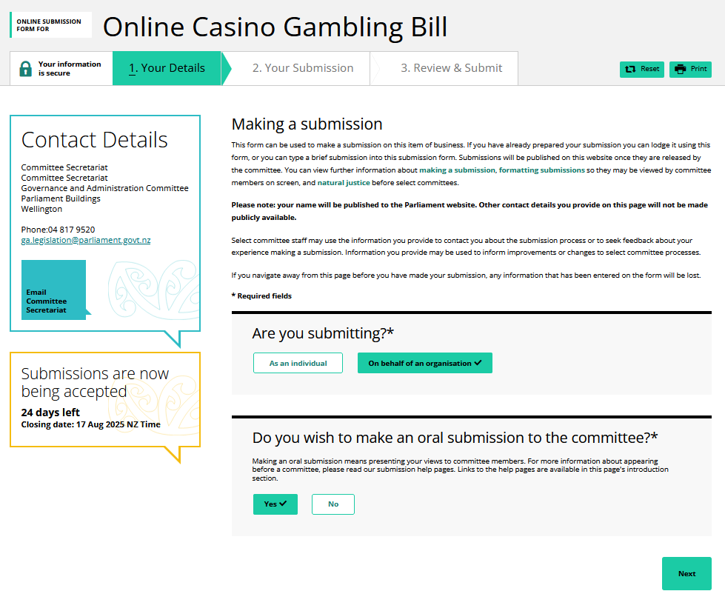
Fill out your details. Preference is for Chairs or role-holders in RSOs / Clubs. | 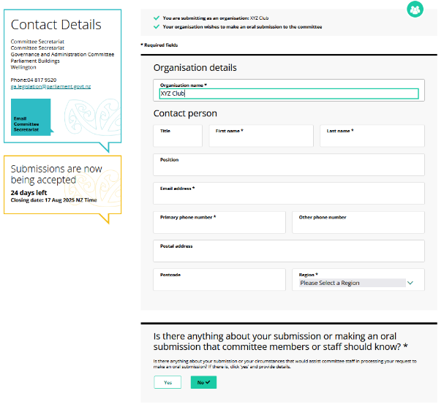
If you have a submission document, click upload submission. A box will help you choose and upload the document from your files. You will then be taken to the final page to confirm your details and complete the submission.  If you are using the online form, follow instructions below:  In the comments field box, insert content from “Summary” and “Main points” in the template submission above – making sure to replace our guiding sentences with your own words.  In the “recommendations” box copy this:  Embed in the Bill the same principle from the Gambling Act 2003 (and the 1977 Gaming and Lotteries Act before it); “Gambling should benefit the community.” Carry this out by requiring that some revenue from online casino gambling is shared with the community, especially sport. | 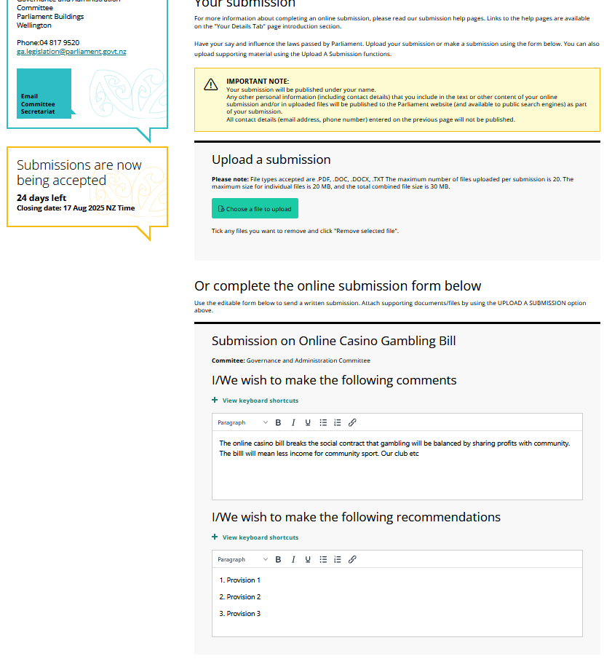
Review submission, tick Privacy Statement, and click Submit. | 



